**August 2020**

**Volume 10, Issue 13**

### 

Department of Georgia Auxiliary News

# A Word from the President

# Z

### 

### 

### Inside This Issue

From President Valerie Brown-Debro 1

Secretary 2

1st Vice President /Leadership 2

2nd Vice President 3

Historian 3

2019 2020 Unit District & Dept Information 4

Miscellaneous Items 5,6

Chaplain 7

Conference/Banquet Forms 8,9

Calendar of Events 10

Con

By Valerie Brown-Debro, Department President

**NEWS UPDATE**

Greetings Angels,





 !



"#$%&'()*()+)+



 !"#!$" !

""$%& '#($#)

$$*"$ +, *%

"$*!!* $!!

!!%-$"!$"$*

 





 !



"#$%&'()*()+)+



 !"#!$" !

""$%& '#($#)

$$*"$ +, *%

"$*!!* $!!

!!%-$"!$"$*

 

Summer is hot and sizzling in GA. We have some good and bad news to share… Fall Conference has been canceled per The Department of GA American Legion. Our ALA Department of GA had our DEC tele- Conference call meeting on Saturday, July 18th. and the membership turnout was low. We must stay in front of our member, the saying out of sight out of mind, Is so true!

I sent out a notice to the District President’s to share with the Units to start practicing the app “ZOOM” meeting. It’s a face to face on the computer so that we can see our members. COVID-19 has changed the way we do things and our members well-being is of the most important concern.

Please continue to work our programs and share the news with our members and community by joining social media, Facebook, Instagram and LinkedIn.

**The ALA Department of GA** had an anonymous donor to donate a **NEW 65”** **Samsung Smart TV** to **raffle** and raise funds earmarked for our ALA Department headquarters. Tickets are **$5.00** and can be distributed digital to your Units, family members and community. The winner will be pulled on **9/11/2020** at our Department Headquarters

Contact our Department Secretary Patty Hawkins to email your ticket form. Patty’s contact information: [secamlegaux@bellsouth.net](mailto:secamlegaux@bellsouth.net) or 678-289-­8446 .

*New Web Page*

[www.aladeptga.com](http://www.aladeptga.com)

come take a peek to see what’s happening

The American Legion’s National membership workshop is going virtual and will be open to anyone who wants to attend. This is a wonderful training opportunity for all our members and an opportunity to learn the Legion perspective. Please do whatever you can to spread the word to all our unit members! Visit alaforveterans.org for more information or see our website [www.aladeptga.com](http://www.aladeptga.com) for information.

I can’t wait to see all of your beautiful faces, sending virtual hugs, stay hydrated, stay safe and stay blessed.

Valerie Brown-Debro

ALA Department President

### 

By Susan Hall, Dept. 1st Vice President

# 1st Vice President/ Leadership

# Secretary

**ALA Members as we go through these trying times, we have been working on different ideas on how we can help our Units. As we all know, times are tough, so due to that fact we are doing things in a different set of ways. The Department Finance Committee and Officers looked at ways to help. This year only we will be combining our Book of Reports, since we have the same President and Officers. So, there will be no charge for the 2020-2021 Book of Reports 😊, but you do have to pay for the 2019-2020, if you haven’t already. Another way of helping is not charging for the Juniors Fund as their funds didn’t get used. All of these changes reflect on the 2020-2021 Obligation Form. I know this is not a lot but every little bit helps.**

**Please note that Obligation are Mandatory Obligations. That means every unit no matter the size must pay each year. If you have not paid you 2019-2020 Obligations, they need to be paid immediately. If you have any questions just call us.**

**\*\*Please make sure all your Department Obligations have been paid. \*\*\***

Notices were sent out to all Units that have not paid some or all obligations. I have received some back but not all. These are Mandatory Obligations and must be paid yearly. If you missed a year the Unit is still responsible to pay, so please take care of the Obligations. I will be sending out another Notice for those that have not paid.

You can find the forms on [www.aladeptga.com](http://www.aladeptga.com), our website under Member Resources. We have lots on important information on the website, so use it. If there is something that you would like to see on the website, send us an email and we will see if we can make it happen.

FALL CONFERENCE HAS BEEN CANCELLED.

Stay Safe and GOD BLESS AMERICA!!!

Pray for ALL OUR Members, their family and above all Peace in all of our lives and this world.

BE KIND!!!!!

By Patty Hawkins, Department Secretary

[Type a quote from the document or the summary of an interesting point. You can position the text box anywhere in the document. Use the Drawing Tools tab to change the formatting of the pull quote text box.]

Happy Fourth of July!

I hope everyone is doing well during these times.

If there is any unit that would like to host a Leadership Workshop for the 2020-2021 year please contact me by phone or email.

Please continue to work on the ALA Academy classes, at [www.alaforveterans.org](http://www.alaforveterans.org) and remember to print out the certificate of completion and forward to me. There are 8 different courses: ALA 101, ALA Communication Methods, ALA Leadership, Establishing a culture of Good Will, ALA Branding, ALA Juniors E-Learning, ALA Fundraising and How to deal with Conflict. Watch for new online courses. The National website is full of information to help your units grow and thrive.

With the Covid-19 still growing here in Georgia there are no Leadership Workshops currently. I hope to have a couple in the 2020-2021 year based on the health emergency.

Stay safe and hope to see you soon. If anyone has any questions, please don’t hesitate to contact me by phone or email.

Susan Hall

1st Vice President

Suem_66@yahoo.com



**Hello ALL!**

**I pray everyone is practicing precautions during this pandemic as cases are rising! Those who are and have been infected with the virus, I send my prayers to you all! It has been a trying time for many of us. We must maintain our faith’s. This too shall pass.**

**Many Units have reopened and are practicing social distancing to prevent the continuous spread of this disease. While doing so, we as Units are continuing to operate as required!**

**Historians, although are minds are full and our hearts are heavy this is a good time to update any of your history files for your Unit. Locate missing photos, update displays and add new entries and insert missing entries to your history records. You can start a display of your Units history if you do not have one. Implement ways in which your Unit can stand out when visitors are present.**

**In next month’s newsletter and forward, I would like to feature an Auxiliary member who has been outstanding in their service not only to the Veterans but to the Organization. Let us get to know each other more closely. If you have a person you would like to feature, please send to my email and I will gladly submit in next month’s newsletter and newsletters, thereafter. I would like a brief but detailed overview of your persons contribution. Include if she was a Junior or not.**

**If your Unit has a male member, tell us about his interaction with the ladies and what impact has it had to your Unit. This should be noted in your running history as well.**

**If I can be of assistance in any way please do not hesitate to reach out to me, even if it’s only to say hello!**

**I miss you all and cannot wait to see you again!**

**Cheryl Jackson-Sinkler**

**Historian**

**Department of Georgia**

**2019-2021**

**770-875-5987**

**Cheryl.jackson08@yahoo.com**

By Pat Morgan, Department 2nd VP

2nd Vice President/Membership

By: Gloria Smith Fox, Chaplain

Hello ALA Georgia Angels!

Thank you for all your hard work serving our Veterans and their families, your communities and our members this past year. As we all adjust to this new “normal” I hope all members and their families are staying safe.

Let’s not forget that you can still pay your 2019-20 membership dues. This is a great time to make that personal wellness check phone call to those members to let them know they are not forgotten and they can renew their membership by paying over the phone to National at 317-569-4570 or online at [www.alaforveterans.org](http://www.alaforveterans.org) . A membership number is required. Also, National has been sending out emails to members so they may pay their 2020-21 dues.

Department still has not received the required forms from numerous Units so the Membership cards can be sent to the proper person. The Unit Officers Yearly Form and the Unit Data Form can be found on the Department Website at aladeptga.com. I understand that due to COVID-19, many units have not held their 2020-21 unit elections. If this is the case, send in the forms with last year’s officers and after your elections an amended form can be filed with the Department. These forms can be mailed or emailed to the department. 2019-20 Department Obligations are still due by many units. The new 2020-21 form can be found on the Department website. 2019 must be paid prior to paying the 2020 obligations.

Thank you for all your continued efforts and if I can assist you in any way, please feel free to contact me by email at [pimorga@aol.com](mailto:pimorga@aol.com) or 2229 Johnson Short Rd., Quitman, GA 31643 or at (229) 561-4070. Pat Morgan

**“Angels Working As One For Veterans”**



By Cheryl Jackson Sinkler, Department Historian

HISTORIAN CORNER



Department Chaplain

**\*\*ATTENTION Changes\*\***

**American Legion Auxiliary Honor Our Female Veterans**

**National will be discontinuing the HONOR FEMALE VETERANS program starting with the 2021 Membership year, the national organization will no longer waive the $12.00 national portion of dues to female veterans that are new members. The Department will follow suit and will not waiver the $11.00.**

**Now that our organization has opened our eligibility to allow male spouses, many of which are veterans themselves, we feel that it is best to retire this program as to not exclude any veteran. In addition, the renewal rate of female veterans who joined through this program has diminished beyond our normal rate of renewals as well as fewer female veterans are joined through this program each year.**

By: Gloria Smith Fox, Chaplain

"God didn't promise days without pain, laughter without sorrow, or sun without rain; but He did promise strength for the day, comfort for the tears, and light for the way. If God brings you to it, He will bring you through it." -Unknown

Just wanted to remind everyone to remain safe. Take the precautions especially those who are more prone to succumb to this Coronavirus. If you know of someone who needs to be careful, be sure to look out for them. Make a phone call. Take all the precautions to keep them safe. And remember to pray for this to bring families closer and look at what is really important in life.

May God bless and keep each one of you till we meet again! And remember...if you wake up in the morning just give God the thanks, and go about His business. With much love and hugs to you all! ...And you all know I AM A HUGGER!!! Gonna have a lot of hugging going on when this is done! Smile....Love you all!

Gloria Smith Fox

Department of Georgia Auxiliary Chaplain

Email: [amlegauxglo@gmail.com](mailto:amlegauxglo@gmail.com)

Cell: 478-293-4043

By: Gloria Smith Fox, Chaplain

**ALA MIS PROGRAM ACCESS for Units/District Membership**

***Monies are DUE into Dept when Access is Requested.***

**The fee is $10 per year per person (2 per Unit). This is the fee National charges. Forms are on the website or call the Department for copies. Due to the enforced rules all forms must be completed and signed by 5 current Unit Officer. At no time is an authorized person using ALA MIS is to share their password with anyone. If a person needs to be changed please send in a new form right away. Please let us know ASAP.**

**If Unit wants to continue having access to the ALA MIS the department must receive new forms and $10 for each person per calendar year.**

**New: District Presidents can now have access to all the Units in their districts. This will be a read only and cannot make any changes. The fee is $10 and will be good until December.**

**DEPARTMENT CHAPLAIN POSITION OPEN**

The Department of Georgia is looking for a Chaplain for the year 2020-2021. If you are interested or know of someone who would like to fill this position please contact Patty Hawkins @ [secamlegaux@bellsouth.net](mailto:secamlegaux@bellsouth.net) or Dept. President Valerie Brown Debro @ [Valerie.debro@yahoo.com](mailto:Valerie.debro@yahoo.com).

Duties of Chaplain: The Department Chaplain shall offer prayer at all Department meetings and perform such other duties as needed.

**ALA DEPARTMENT OF GA 2019-2020 REPORTS**

**UNITS * DISTRICTS * DEPARTMENT**

ALA Members in GA **will continue** with the Program Action Reporting for 2019-2020. If you sent in a report from your Unit or District to one of the Department Chairpersons, **please see** the information below on How we are proceeding with the reporting for 2019-2020 in Georgia.

We are requesting for all GA members to **submit your report** To the Department Chairperson with completed **FORMS** that are **due by May 1, 2020** The report forms are located on our Department website. [www.ALADept.com](http://www.aladept.com/)

**YEARBOOKS** Books were due by **February 15th** Leadership Chairperson **Susan Hall** already judged the books and will announce winner of Yearbooks. If you sent a yearbook in for judging, contact her on how to receive your book in return.

**PRAYER BOOKS: NO JUDGING** Still send REPORT **FORMS** to Department Chaplain **Gloria Fox Smith**.

**HISTORY BOOKS NO JUDGING** Still send REPORT **FORMS** to Department Historian. **Cheryl Jackson Sinkler**

**SCRAPBOOKS NO JUDGING** Still send REPORT **FORMS** - **Kathy Browder-Woods.**

**PLEASE “DO NOT” Send any reports NATIONAL –** Per updates due to **COVID-19 National** will receive reports in **a 2 year** reporting period 2019-2020 & 2020-2021 **Mid-Year** reports due January 5th , **Year-end** due May 15, 2021 [www.alaforveterans.org](http://www.alaforveterans.org/)

**YEAR END IMPACT REPORT FORMS 2019-2020**: **due April 30, 2019** Everyone

Please submit a [**Year End report** for **Member**, **Unit**, **District**](https://69382598-56b5-49ef-a656-bea0a8f39b0f.filesusr.com/ugd/76bc83_c060370d9bd0410b9c066c3fceace361.pdf) Department Every **hour**, every **dollar** , Our service for Veterans. Active -Duty- Retired/ Military, families and Community. every mile driven. Scholarships, Girls State, Children & Youth, Community Service, members invest in our mission of helping veterans adds up, they are also reported to the American Legion which includes them in its annual report to congress.

**BOOK OF REPORTS:** Department Officer and Chairman still submit your annual report **due June 15, 2020** send your copy to [Valerie.Debro@yahoo.com](mailto:Valerie.Debro@yahoo.com) and Secretary Patty Hawkins [secamlegaux@bellsouth.net](mailto:secamlegaux@bellsouth.net) Please follow Book of Reports Rules on our Department Website. [www.ALADeptGA.com](http://www.aladeptga.com/)

IN THE KNOW

Please read the message below so that you informed on all the happening that is going on with the American Legion Auxiliary and The American Legion.

**Information is KNOWLEDGE!!!**

TO: **National Executive Committee Members, National Officers, National Chairmen, Past National Presidents**

CC: **Department Presidents; Department Secretaries, NHQ Staff**

From: Kelly Circle, Executive Director

Re: **Weekly Briefing 7-24-2020**

The American Legion’s membership workshop is going virtual and will be open to anyone who wants to attend. Members just have to click on “Attendee Link” in the attached agenda for the session they want to attend about 15 minutes before it starts. This is a wonderful training opportunity for all our members and an opportunity to learn the Legion perspective. Please do whatever you can to spread the word to all of our unit members!

Also attached is a flyer for the 2020 Show Your Love Contest.  This is another request to do whatever you can to get this information to all of our unit members. It would be nice to see one of our own win the grand prize considering all the wonderful things we have seen in local communities in the last few month!

Shannon Hitchcock, Director of HR, and I have been busy reviewing some Inclusion & Division training modules. LinkedIn has some really good, and FREE, trainings and I encourage everyone to take a look at them. In particular, I highly recommend “Confronting Bias: Thriving Across Our Differences” and “Bystander Training: From Bystander to Upstander.” All of these trainings are based in the employment setting but are easily transferrable to our organization. Here’s the link to the trainings: <https://learning.linkedin.com/blog/linkedin-learning-resources/free-courses-to-help-you-become-a-stronger-ally-and-have-inclusi>

Please share this link with everyone you can so ALL members can benefit!

On Monday and Tuesday, the directors will be meeting with the Strategic Planning Committee to present their division plans. The directors have put much time and thought into planning the activities, and I’m so appreciative of their efforts. I’m confident the committee will be impressed with their efforts as well.

The agenda is below. This could be a great Family Activity.

**AGENDA**

**57TH ANNUAL NATIONAL MEMBERSHIP WORKSHOP**

VIRTUAL THROUGH MICROSOFT TEAMS AUGUST 3-6, 2020

**GROWING A POST**

MONDAY, AUGUST 3, 2020

**4:00 PM – 5:00 PM TOPIC: THIS IS THE AMERICAN LEGION**

*Basic Introduction To The American Legion*

Presenter: Matt Herndon (IN), IA&Membership Division [Attendee Link](https://teams.microsoft.com/l/meetup-join/19%3ameeting_ZDc1YWIyMWUtYTMyMC00NTE5LWFmMzEtZGY4YjhkOWE1NmE1%40thread.v2/0?context=%7b%22Tid%22%3a%22dd9d243c-8688-470f-8812-4ceb7ac50b6c%22%2c%22Oid%22%3a%221b1a8731-9646-4529-bb68-46a159372bf6%22%2c%22IsBroadcastMeeting%22%3atrue%7d):

**7:00 PM – 8:00 PM TOPIC: MISSION & VISION**

*Focuses On The Importance Of Developing A Mission* Statement And Having A Vision Towards The Future

Presenter: Ron Neff (IN), IA&Membership Division [Attendee Link](https://teams.microsoft.com/l/meetup-join/19%3ameeting_ZTdmYjYzYmMtNmI0My00NDZlLTkxMDUtZGJlZGNjZWJiZDM1%40thread.v2/0?context=%7b%22Tid%22%3a%22dd9d243c-8688-470f-8812-4ceb7ac50b6c%22%2c%22Oid%22%3a%221b1a8731-9646-4529-bb68-46a159372bf6%22%2c%22IsBroadcastMeeting%22%3atrue%7d):

TUESDAY, AUGUST 4, 2020

**4:00 PM – 5:00 PM TOPIC: BUILDING AN EFFECTIVE MEMBERSHIP TEAM**

*How To Organize A Membership Team That Focuses On A* Clear Goal Through A Developed Plan Of Action

Presenter: Kevin Mook (MD), IA&Membership Division [Attendee Link](https://teams.microsoft.com/l/meetup-join/19%3ameeting_Y2UwOTZiN2MtM2Q5NS00NTc3LWE0ZGUtMmUyZGU5NzIyZGNh%40thread.v2/0?context=%7b%22Tid%22%3a%22dd9d243c-8688-470f-8812-4ceb7ac50b6c%22%2c%22Oid%22%3a%221b1a8731-9646-4529-bb68-46a159372bf6%22%2c%22IsBroadcastMeeting%22%3atrue%7d):

**7:00 PM – 8:00 PM TOPIC: RECRUITMENT OF VOLUNTEERS**

*How To Locate And Keep Legionnaires Engaged* Presenter: Doug Chace (IN), IA&Membership Division [Attendee Link](https://teams.microsoft.com/l/meetup-join/19%3ameeting_MTQ2MTNlZDktODQ1OS00NDFhLTllNTgtODhjNzUxNGVhNjdj%40thread.v2/0?context=%7b%22Tid%22%3a%22dd9d243c-8688-470f-8812-4ceb7ac50b6c%22%2c%22Oid%22%3a%221b1a8731-9646-4529-bb68-46a159372bf6%22%2c%22IsBroadcastMeeting%22%3atrue%7d):

WEDNESDAY, AUGUST 5, 2020

**4:00 PM – 5:00 PM TOPIC: MEMBERSHIP RETENTION**

*Focuses On Growing Membership Through Retention* Presenter: Michele Steinmetz (CA), IA&Membership Division [Attendee Link](https://teams.microsoft.com/l/meetup-join/19%3ameeting_YWJkMWQ3NGEtNmM3NS00N2U5LWFmNjYtYTBjYmVmNTQ0NjFj%40thread.v2/0?context=%7b%22Tid%22%3a%22dd9d243c-8688-470f-8812-4ceb7ac50b6c%22%2c%22Oid%22%3a%221b1a8731-9646-4529-bb68-46a159372bf6%22%2c%22IsBroadcastMeeting%22%3atrue%7d):

**7:00 PM – 8:00 PM TOPIC: EVERY LEGIONNAIRE IS A RECRUITER**

*Focuses On Growing Membership Through Recruiting* Presenter: Ron Neff (IN), IA&Membership Division [Attendee Link](https://teams.microsoft.com/l/meetup-join/19%3ameeting_ZjNhNmRhNWQtYTk3Ni00Njg5LTk5MWMtMGVkNTY3ZWU3YzUx%40thread.v2/0?context=%7b%22Tid%22%3a%22dd9d243c-8688-470f-8812-4ceb7ac50b6c%22%2c%22Oid%22%3a%221b1a8731-9646-4529-bb68-46a159372bf6%22%2c%22IsBroadcastMeeting%22%3atrue%7d):

THURSDAY, AUGUST 6, 2020

**4:00 PM – 5:00 PM TOPIC: DEFINE A GREAT POST**

*Discusses Ways For Posts To Be An Asset In The Community* Presenter: Doug Chace (IN), IA&Membership Division [Attendee Link](https://teams.microsoft.com/l/meetup-join/19%3ameeting_Yjg4OTAzYzQtY2YxNi00MDVhLTg4NDctMDJmMjA2ZTdmM2Rl%40thread.v2/0?context=%7b%22Tid%22%3a%22dd9d243c-8688-470f-8812-4ceb7ac50b6c%22%2c%22Oid%22%3a%221b1a8731-9646-4529-bb68-46a159372bf6%22%2c%22IsBroadcastMeeting%22%3atrue%7d):

**7:00 PM – 8:00 PM TOPIC: MYLEGION FOR THE POSTS**

*Online Membership Tools For Post Adjutants* Presenter: Libby Vickers, IT Division [Attendee Link](https://teams.microsoft.com/l/meetup-join/19%3ameeting_MTdhYzFiM2ItZTIxZC00NzRhLWJkNjUtZDI2M2NiMzMwOWEy%40thread.v2/0?context=%7b%22Tid%22%3a%22dd9d243c-8688-470f-8812-4ceb7ac50b6c%22%2c%22Oid%22%3a%221b1a8731-9646-4529-bb68-46a159372bf6%22%2c%22IsBroadcastMeeting%22%3atrue%7d):

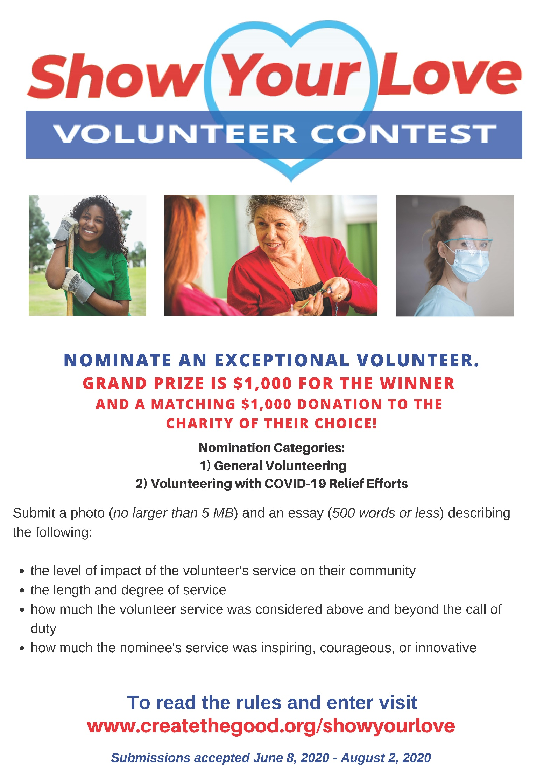

Greetings American Legion Family, Friends & Community!

The American Legion Auxiliary Department of GA Headquarters is raffling a 65"Samsung UHD TV. Tickets are available for **$5.00 each**. The **winning ticket** will be pulled **9/11/2020** **September 11, 2020** at our ALA Department Headquarters. Since COVID-19 and meeting the CDC guidelines of social distancing, we have created a simple digital form that can be emailed to share with members, family and friends and community.

Attached are digital forms that you could complete online by typing in your **Name**, **Phone number** and **Post/Unit** **#**or you could print them on hard copy to distribute.

**Form 1** has **(1) T**icket **or** **Form 2** has **(3)** Tickets per page. (Save form for your records) They can easily be shared through email.  **To complete form**, fill in Name/ Phone/ Post/Unit and send to ALA Department Headquarters with payment amount to match tickets.

Presidents challenge, whoever sells the most tickets, will win my President's Challenge Coin. **(1st - 5th Place Winners)**

Return a hard copy of the ticket form with payment method to our ALA Department Headquarters.

**Make Checks or Money order payable to:**

ALA Department of GA Headquarters

3035 Mt. Zion Rd.

Stockbridge, GA 30281

**ATTN:** ALA Department Secretary Patty Hawkins

[**secamlegaux@bellsouth.net**](mailto:secamlegaux@bellsouth.net) (678 289-8446)

Thank you for all that you do in serving together, For God & Country.

9/11 Angels Serving Every Veteran.

Valerie Brown-Debro

ALA Department of GA

President

404 201-5138

[Valerie.Debro@yahoo.com](mailto:Valerie.Debro@yahoo.com)

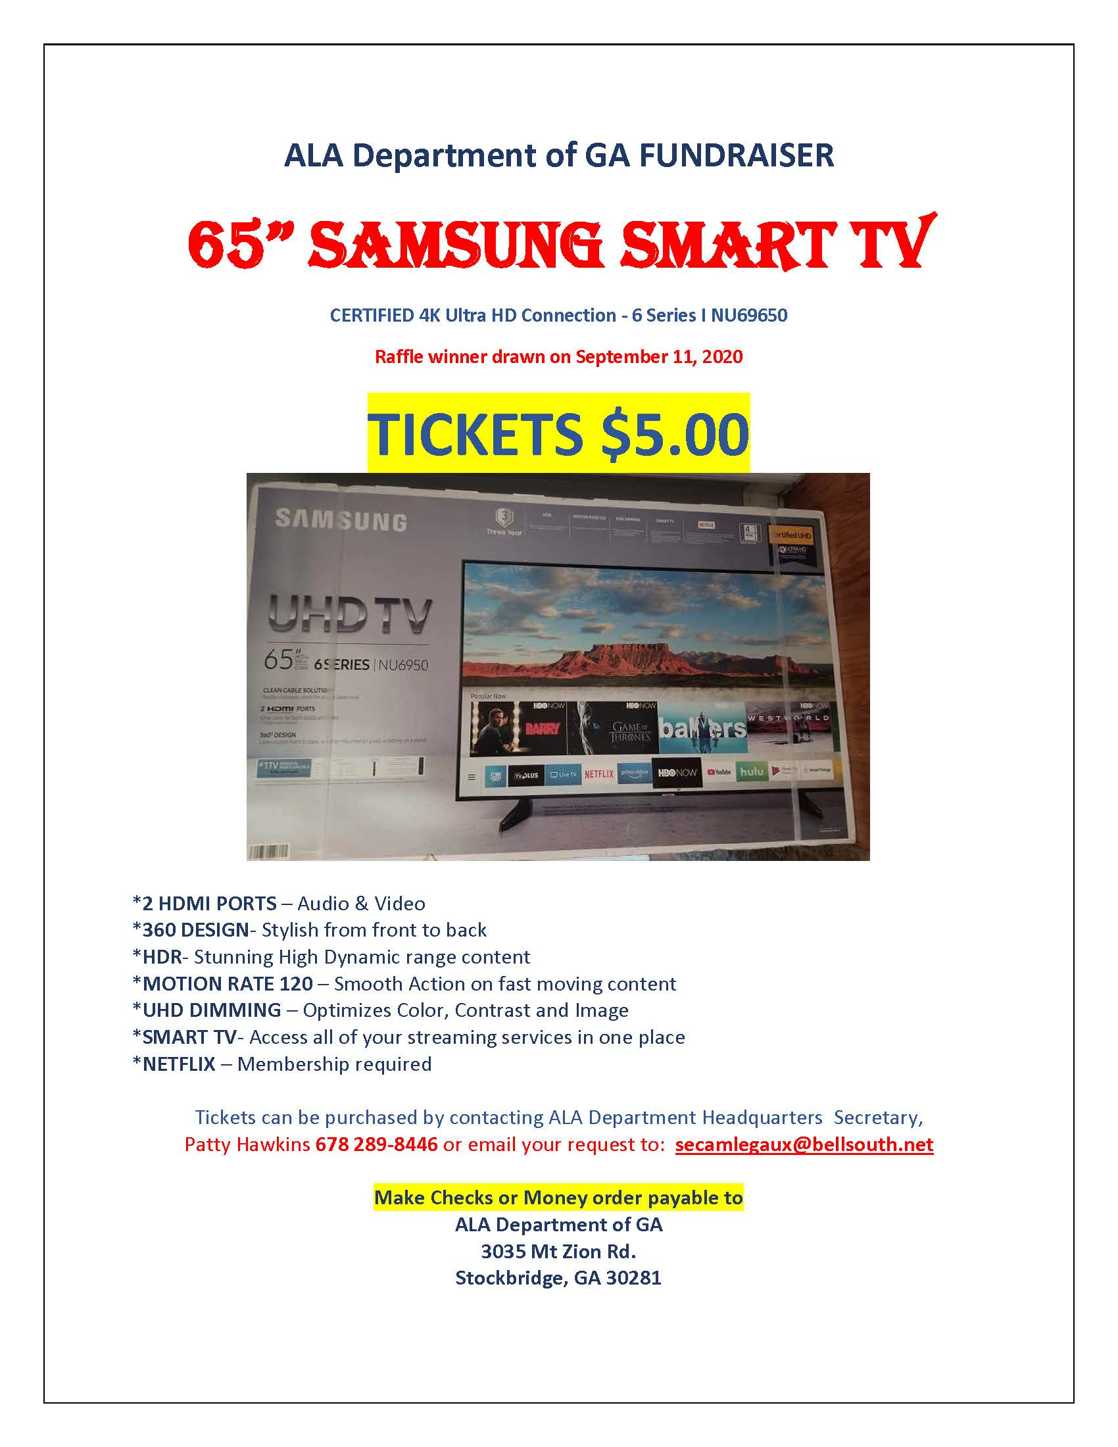

***n Form***

**Calendar of Upcoming Events 2020**

**August 2, 2020 National Friendship Day**

**September 7, 2020 Labor Day (office closed)**

**September 11, 2020 Patriot Day**

**September 13, 2020 National Grandparents Day**

**TV Raffle: All Tickets must be into the Office by September 10th, Drawing will be 9-11-2020.**

***DEPARTMENT FALL CONFERENCE***

OCTOBER 16-18, 2020

***Has been cancelled as of July 23, 2020***

|  |  |  |
| --- | --- | --- |
|  |  |  |
|  |  |  |
|  |  |  |
|  |  |  |
|  |  |  |

**Happy 100th Birthday American Legion Auxiliary!!!!!**

**“ A Century worth Celebrating”**

**NOVEMBER 10, 1919 - 2019**

**Still going strong 😊**

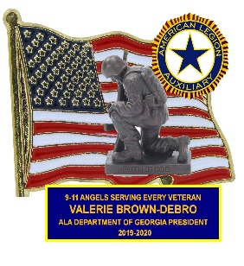

**President’s Theme:**

**“9-11 Angels Serving Every Veteran”**

**Membership Theme:**

**“Angels Working As One For Veterans”**

**National President’s Theme:**

**“A Century worth Celebrating”**

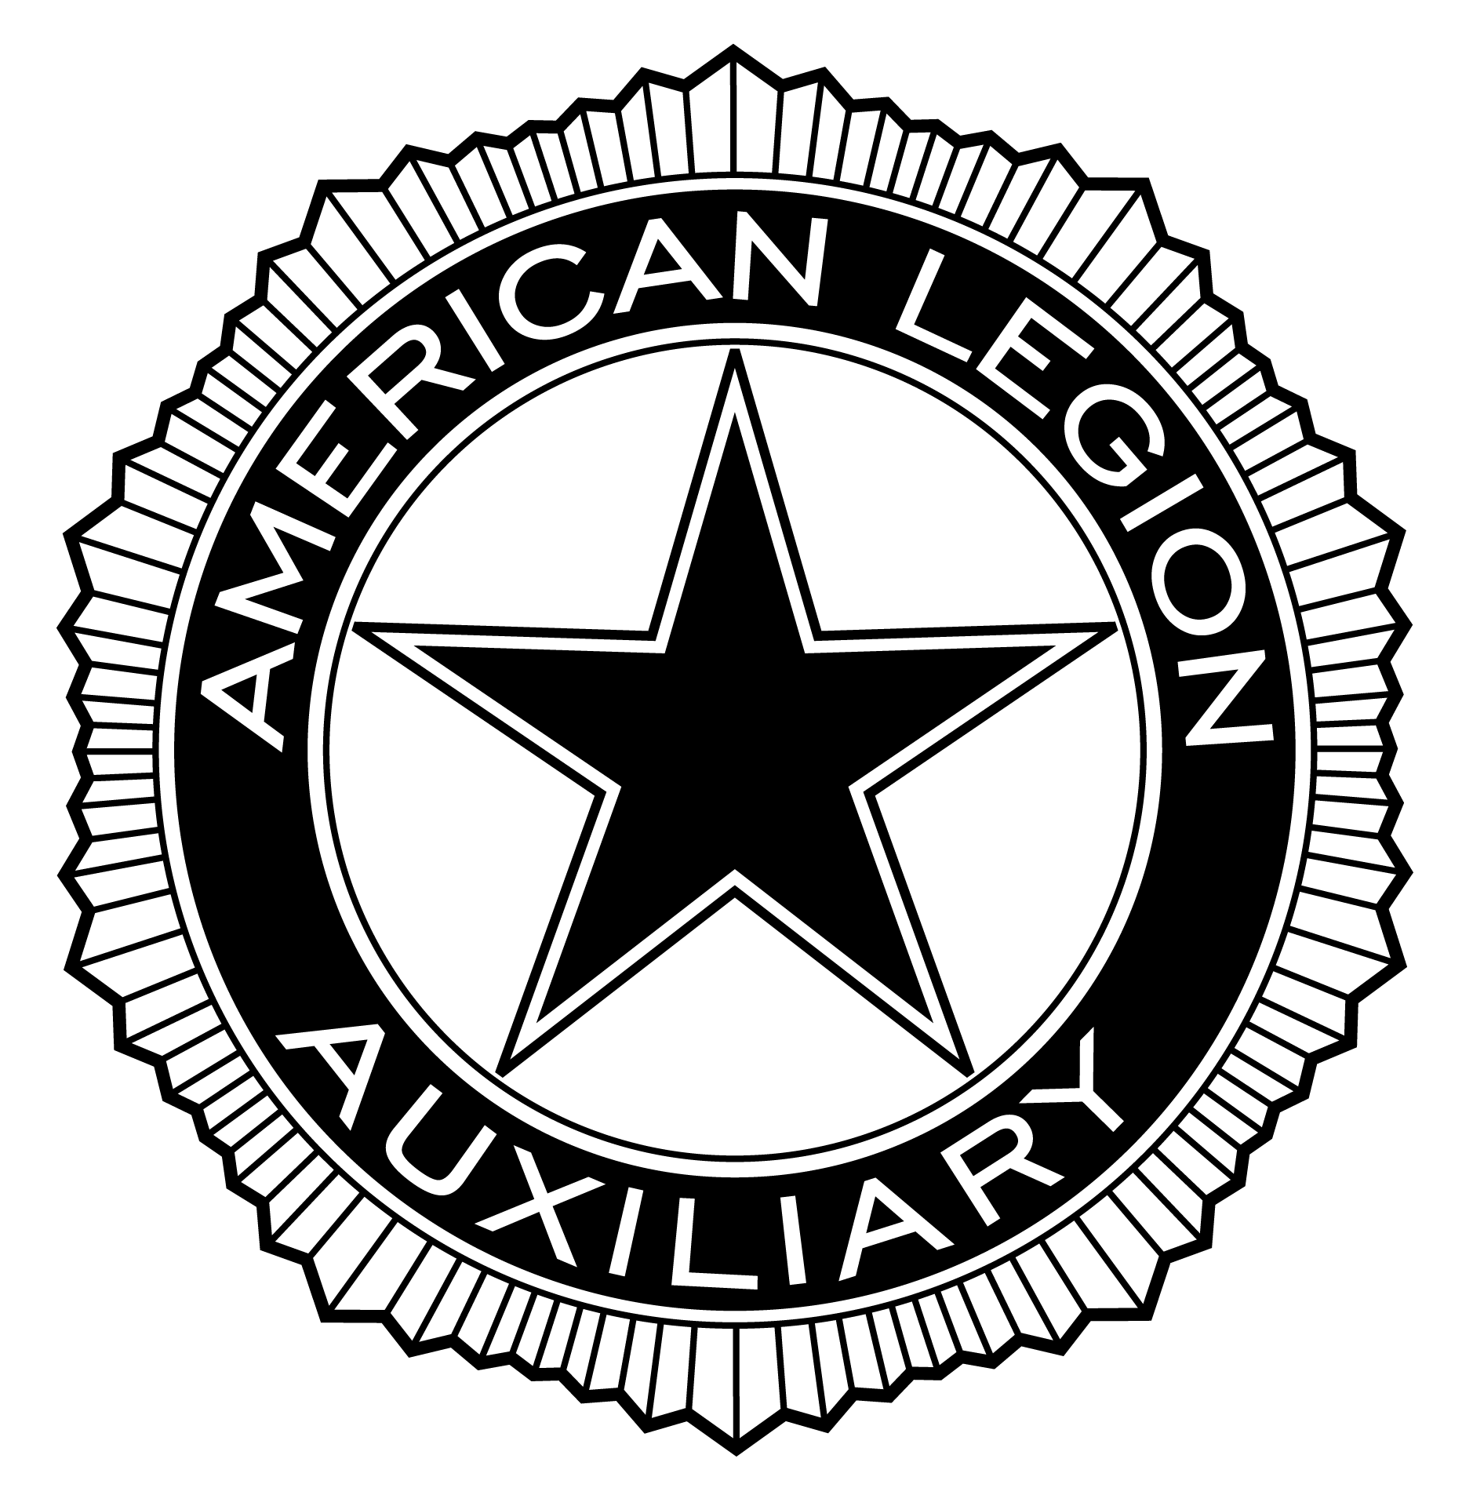

American Legion Auxiliary

Department of Georgia

3035 Mt Zion Rd

Stockbridge, GA 30281

